RFP 23-5381

REQUEST FOR PROPOSAL (RFP)
FOR GOODS

Project Title: | Safe and sustainable drinking water for Kiritimati Island
Nature of the goods | Supply and delivery of Wind pumps and technical assistance for the Kiritimati Island Water Project
Location: | Kiritimati Island, Kiribati
Date of issue: | 12/05/2023
Closing Date: | 11/06/2023
SPC Reference: | RFP23-5381

Contents
Part 1: INTRODUCTION 3
Part 2: INSTRUCTIONS TO BIDDERS 4
Part 3: Specification of Goods 8
Part 4: PROPOSAL EVALUATION MATRIX 21
Part 5: PROPOSAL SUBMISSION FORMS 23
Annex 1: BIDDER’S LETTER OF APPLICATION 23
Annex 2: CONFLICT OF INTEREST DECLARATION 24
Annex 3: INFORMATION ABOUT THE BIDDER AND DUE DILIGENCE 26
Annex 4: TECHNICAL PROPOSAL SUBMISSION FORM 29
Annex 5: FINANCIAL PROPOSAL SUBMISSION FORM 32

Part 1: INTRODUCTION

1.1 About the Pacific Community (SPC)
The Pacific Community (SPC) is the principal scientific and technical organisation of the Pacific region, established by treaty in 1947 with the signing of the Agreement Establishing the South Pacific Commission (the Canberra Agreement).
SPC has our headquarters in Noumea, New Caledonia and has regional offices in Fiji, the Federated States of Micronesia and Vanuatu, as well as an office in France. SPC works across the Pacific and has staff in nearly all of our Pacific Island Country and Territory members.
SPC works for the well-being of Pacific people through the effective and innovative application of science and knowledge and is guided by a deep understanding of Pacific Island contexts and cultures. Our unique organisation covers more than 20 sectors and is renowned for knowledge and innovation in such areas as fisheries science, public health surveillance, geoscience and conservation of plant genetic resources for food security.
For more information about SPC and the work that we do, please visit our website: https://www.spc.int/.

1.2 SPC’s procurement activities
SPC’s procurement activities are guided by the principles of high ethical standards, value for money, open competition and social and environmental responsibility and are carried out under our Procurement Policy.
SPC’s Procurement Policy provides the framework for ensuring that SPC obtains the best value for its purchases, in terms of both cost and quality; demonstrates financial probity and accountability to its members and development partners; manages and prevents the potential for conflicts of interest; reduces its environmental impact and manages any other risks.
At SPC, all procurement follows the same main steps: planning; statement of needs; requisition; solicitation; evaluation; award; receipt; and payment. Different procedures apply depending on the value of the goods, services and works to be procured.
For further information or enquiries about SPC’s procurement activities, please visit the procurement pages on our website: https://www.spc.int/procurement or email: procurement@spc.int.

1.3 SPC’s Request for Proposal (RFP) Process
At SPC, procurement valued at more than EUR 45,000 must be advertised through a Request for Proposal (RFP) with any bids received evaluated by SPC’s Procurement Committee to determine the offer that provides the best value for money.
This RFP sets out SPC’s requirements and it asks you, as a bidder, to respond in writing in a prescribed format with pricing and other required information. The RFP contains detailed instructions and templates to enable you to submit a compliant bid. It sets out the overall timetable; it confirms the evaluation criteria that SPC will use to evaluate quotations; it explains the administrative arrangements for the receipt of the bids; and it sets out how bidders can request further information.
Your participation confirms your acceptance of SPC’s conditions of participation in the RFP process.

Part 2: INSTRUCTIONS TO BIDDERS

2.1 Background
SPC invites you to submit a bid to deliver the goods as specified in Part 3.
SPC has advertised this RFP on its website and may send it directly to potential vendors. The same specifications, submission and other solicitation requirements will be provided to all vendors.
SPC has compiled these instructions to guide prospective bidders and to ensure that all bidders are given equal and fair consideration.
Please read the instructions carefully before submitting your bid. For your bid to be considered, you must provide all the prescribed information by the closing date and in the format specified.

2.2 Submission instructions
Your submission must be clear, concise and complete and should only include information that is necessary to respond effectively to this RFP. Please note that you may be marked down or excluded from the procurement exercise if your submission contains any ambiguities or lacks clarity.
Your proposal must include the following documents:
- Bidder’s Letter of Application (Annex 1);
- Conflict of Interest Declaration (Annex 2);
- Information about the bidder and Due diligence (Annex 3);
- Technical proposal submission form (Annex 4);
- Financial proposal submission form (Annex 5).
Your proposal must be submitted in two separate emails.
You must submit your Technical proposal (Annexes 1 to 4 and all their supporting documents) in English as an attachment to one email. No financial information may appear in the technical proposal.
You must submit your Financial proposal (Annex 5) in a separate email. All prices in the proposal must be presented in AUD. Your Financial proposal is to be password protected. SPC will request the password in the event that it is required.
Both emails are to be sent to procurement@spc.int with the subject line of your email as: Submission RFP23-5381.
Your proposal must be received no later than 11/06/2023 by 11.45pm Fiji Time GMT +12. Only one bid per bidder is permitted.
SPC will send a formal acknowledgement to each proposal received before the deadline.
SPC reserves the right to exclude from consideration any proposal not received by the deadline, with complete information or in incorrect form.

2.3 Clarifications
You may submit questions or seek clarifications on any issue relating to this RFP. The questions are to be submitted in writing to procurement@spc.int with the subject line: Clarification RFP23-5381. The deadline for submission of clarifications is 26/05/2023 by 11.59PM Fiji Time GMT +12.
Details will be kept of any communications between SPC and bidders. This assists SPC to ensure transparency of the procurement process. While SPC prefers written communication in the RFP process, at any point where there is phone call or other conversation, SPC will keep a record or a file note of the exchange with prospective bidders.

2.4 Evaluation

Validity
Each proposal will be assessed for compliance with the submission requirements by the Bids Opening Committee. At this stage, basic due diligence will also be undertaken.
To assist in the examination, evaluation and comparison of proposals, SPC may ask the bidder for clarification of its proposal or additional information. The request for clarification will be in writing.

Technical
All valid proposals will be assessed against the technical evaluation criteria set out in Part 4. The criteria are provided with weighted scores according to the relative importance of each. SPC will not change the evaluation criteria set out in the RFP at any stage of the procurement process. Any changes in the evaluation criteria will result in the RFP process being re-issued.
Bidders are expected to familiarise themselves with local conditions and take these into account in preparing their proposal. Where minimum qualifications are set as specific evaluation criteria, these could include educational qualification, professional accreditation or certification, licensing, experience and expertise.

Financial
Any bids that pass the minimum technical evaluation requirements will pass onto financial evaluation.
During the financial evaluation, if there is a discrepancy between the unit price and the total price, the lower price shall prevail. If there is a discrepancy between words and figures the amount in words will prevail.
The total cost of the proposal is to be inclusive of any taxes and is not subject to revision.

2.5 Contract award
SPC may award the contract once the Procurement Committee has determined that a bidder has met the prescribed requirements and the bidder’s proposal has been determined to be the most responsive to the RFP documents, provide the best value for money and best serve the interests of SPC.
SPC’s General Terms and Conditions of Contract will apply to any contracts awarded under this RFP, unless otherwise agreed. Any requested changes to the General Terms and Conditions of Contract must be foreshadowed in the submission.
The award of the contract will be made by contract signed and dated by both parties.

2.6 Key dates
Please see the proposed procurement timetable in the table below. This timetable is intended as a guide only and while SPC does not intend to depart from the timetable, it reserves the right to do so at any stage.
STAGE | DATE
RFP advertised | 12/05/2023
Deadline for seeking clarification | 26/05/2023
RFP Closing Date | 11/06/2023
Award of Contract | 10/07/2023
Commencement of Contract | 12/07/2023
Conclusion of Contract | 25/06/2024

2.7 Legal and compliance
Child and vulnerable adult protection: SPC is committed to the well-being of children and vulnerable adults. All SPC contractors are required to commit to the principles of SPC’s Child and Vulnerable Adult Protection Policy (XI.G Manual of Staff Policies). Breach of this requirement can result in SPC terminating any contract with a successful bidder. Any allegations of potential misconduct in relation to this RFP involving children or vulnerable adults should sent to complaints@spc.int.
Confidentiality: Unless otherwise agreed by SPC in advance or where the contents of the RFP are already in the public domain when shared with the bidder, bidders shall at all times treat the contents of the RFP and any related documents as confidential. SPC will also treat the information it receives from the bidders as confidential.
Conflict of interest: Bidders must take all necessary measures to prevent any situation of conflict of interest. You must notify SPC in writing as soon as possible of any situation that could constitute a conflict of interest during the RFP process. If you have any familial connection with SPC staff, this must be declared, and approval will then be sought for you to engage in the RFP process. Breach of this requirement can result in the exclusion of the bidder from the RFP process or in SPC terminating any contract with a successful bidder.
Cost of preparation of quotations: Under no circumstances will SPC be liable for any proposal submission costs, expenditure, work or effort that you may incur in relation to your provision of a proposal (including if the procurement process is terminated or amended by SPC).
Currency, validity, duties, taxes: Unless specifically otherwise requested, all proposals should be in AUD and must be net of any direct or indirect taxes and duties and shall remain valid for 120 days from the closing date. The successful bidder is bound by their proposal for a further 60 days following notification they are the preferred bidder so that the contract may be awarded. No price variation due to escalation, inflation, fluctuation in exchange rates, or any other market factors shall be accepted at any time during this period.
Eligibility: Bidders are required to disclose to SPC whether they are subject to any sanction or temporary suspension imposed by any international organisation, or whether they are subject to bankruptcy proceedings. You may not be bankrupt or suspended, debarred, or otherwise identified as ineligible by any international organisation. Failure to disclose such information may result in debarment and termination of any contract issued to the bidder by SPC.
Fraud and corruption: SPC has zero tolerance for fraud and corruption. All contractors have an obligation to report potential fraud and corruption. Breach of this requirement can result in the exclusion of the bidder from the RFP process or in SPC terminating any contract with a successful bidder. Allegations of potential misconduct by an SPC staff member or contractor involving fraud or corruption can be sent to complaints@spc.int.
Good faith: The information in this RFP is provided by SPC in good faith. No representation, warranty, assurance or undertaking (express or implied) is or will be made, and no responsibility or liability will be accepted by SPC in relation to the adequacy, accuracy, completeness or reasonableness of this RFP or any information provided by SPC in relation to this RFP.
Modifications: Any clarifications, corrections or modifications will be published on the SPC website prior to deadline. In the event a bidder has submitted a bid before the clarification, correction or modification, the bidder will be informed and may modify the bid. The modified bid will still need to be received before the deadline.
No offer of contract or invitation to contract: This RFP is not an offer to contract or an invitation by SPC to enter into a contract with you.
Privacy: The bidder is to comply with the requirements of applicable legislation and regulatory requirements in force for the use of personal data that is disclosed for the purposes of this RFP. SPC will handle any personal information it receives under the RFP in line with its Privacy Policy, and the Guidelines for handling personal information of bidders and grantees.
Right to amend, seek clarity, withdraw, not award: SPC reserves the right to: (1) amend, add to or withdraw all or any part of this RFP at any time, or to re-invite bids on the same or any alternative basis; (2) seek clarification or documents in respect of any bidder’s submission; (3) choose not to award a contract as a result of this RFP; (4) make whatever changes it sees fit to the timetable, structure or content of the procurement process, depending on approvals processes or for any other reason. Please note that while SPC will not change the evaluation criteria set out in the RFP without the RFP process being re-issued, SPC does reserve the right at the time of award of contract to vary the quantity of services and goods specified in the RFP and to accept or reject any proposal at any time prior to award of the contract without incurring any liability to the affected bidder or any obligation to inform the affected bidder/s of the grounds for SPC’s action.
Right to disqualify: SPC reserves the right to disqualify: (1) any bidder that does not submit a proposal in accordance with the instructions in this RFP; (2) any bidder that misrepresents information to SPC; (3) any bidder that directly or indirectly canvasses any SPC employee concerning the award of a contract.
Use of material: Bidders shall not use the contents of the RFP or any related material for any purpose other than for the purpose of considering submitting, or submitting, a bid to SPC.
Warranty, representation, assurance, undertaking: The bidder acknowledges and agrees that no person has any authority to give any warranty, representation, assurance or undertaking on behalf of SPC in connection with any contract which may (or may not) follow on from this RFP process.

2.8 Complaints process
Bidders that consider they were not treated fairly during any SPC procurement process may lodge a protest. The protest should be addressed to complaints@spc.int. The bidder must provide the following information: (1) full contact details; (2) details of the relevant procurement; (3) reasons for the protest, including how the alleged behaviour negatively impacted the bidder; (4) copies of any documents supporting grounds for protest; (5) the relief that is sought.

RFP 23-5381

Part 3: Specification of Goods

Background/context
The EU- and MFAT-funded Safe and sustainable drinking water for Kiritimati Island project, otherwise known as the Kiritimati Island Water Project, is being implemented by The Pacific Community (SPC) in partnership with the Ministry of Line and Phoenix Islands Development (MLPID) and other Government of Kiribati (GoK) stakeholders.
This is the third major water project on Kiritimati Island in the past 25 years. The AusAID funded Kiritimati Water and Sanitation Project (KWASP) was implemented by the Overseas Projects Corporation of Victoria (OPCV) in the late 1990s and early 2000s. Part of the KWASP scope included installation of 15 groundwater infiltration galleries, some of which were fitted with 10-foot Yellowtail wind pumps with 40-foot towers (eight in total) supplied by WD Moore & Co.
In 2013, an Aermotor wind pump donated by Rotary was installed at Banana freshwater lens.
SPC then implemented the EU and NZ MFAT funded Improved Drinking Water Supply for Kiritimati Island Project (IDWSKIP) from 2014 to 2018. Additional to new gallery construction and solar pump installations, IDWSKIP involved the relocation and rehabilitation of several of the Yellowtail wind pumps, including replacement/repair of wind wheels, towers and pump assemblies.
The Kiritimati Island Water Project is a continuation of the IDWSKIP and is presently undergoing detailed design for new and upgraded water system systems. Part of the project scope involves:
- Decommissioning three Yellowtail wind pumps at the Decca freshwater lens that currently shade the solar pump PV generator adjacent to the respective wind tower. Usable parts from these pumps will be kept as spares for the operational wind pumps.
- Rehabilitation of 1 Aermotor and 6 Yellowtail wind pumps at Decca (2), Four Wells (1), Banana (3) and NZ Airfield freshwater lenses (1).
- Installation of a new 10-foot Southern Cross wind pump on 30-foot tower at Banana freshwater lens.
MLPID’s crane will be used to assist with the decommissioning, rehabilitation and installation of wind pumps, as needed.
The table below summarises the works planned on each of the wind pumps at Kiritimati.

Table 1. Summary of Kiritimati wind pump works required
Lens | Gallery & pump well | Wind pump installed | Status | Action | Scope*
Decca | 1 West | 10ft Yellowtail on 40ft tower | Operational (low output) | Decommission | Dismantle; keep parts for spares
 | 2 West | 10ft Yellowtail on 40ft tower | Operational | Rehabilitate | Replace compensator
 | 2 East | 10ft Yellowtail on 40ft tower | Standby | Rehabilitate | General maintenance
 | 3 Centre | 10ft Yellowtail on 40ft tower | Not operational | Decommission | Dismantle; keep parts for spares
 | 3 East | 10ft Yellowtail on 40ft tower | Not operational | Decommission | Dismantle; keep parts for spares
Four Wells | 3 West | 10ft Yellowtail on 40ft tower | Operational | Rehabilitate | General maintenance
Banana | 1 West | 10ft Yellowtail on 40ft tower | Operational (low output) | Rehabilitate | Replace pump assembly and windwheel
 | 1 East | 10ft Yellowtail on 40ft tower | Operational (low output) | Rehabilitate | Replace pump assembly, windwheel and furl handle
 | 2 East | None | Unused pump well | New install | Install new Southern Cross wind pump
 | 3 West | 8ft Aermotor on 27ft tower | Not operational | Rehabilitate | Recentre over pump well (adjust anchors)
NZ Airfield | 1 East | 10ft Yellowtail on 40ft tower | Not operational | Rehabilitate | General maintenance
*Additional to the scope listed, all rehabilitated wind pumps will have their towers and wind wheels painted and repaired as needed, gearboxes filled with oil, drive rods assemblies replaced if needed, furling pull-out wires replaced and leather buckets replaced.

Below are photos of each of the wind pumps to be rehabilitated.
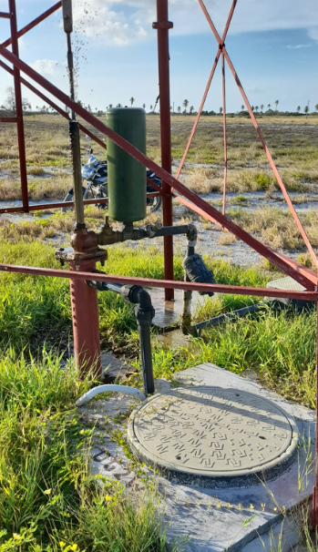
Figure 1. Decca gallery 2 West

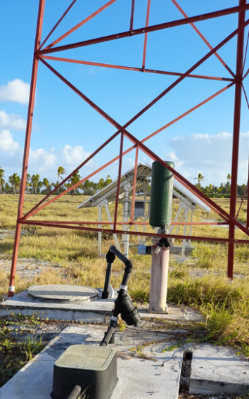
Figure 2. Decca gallery 2 East

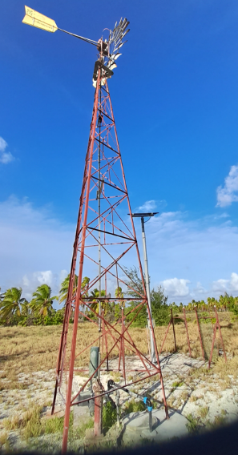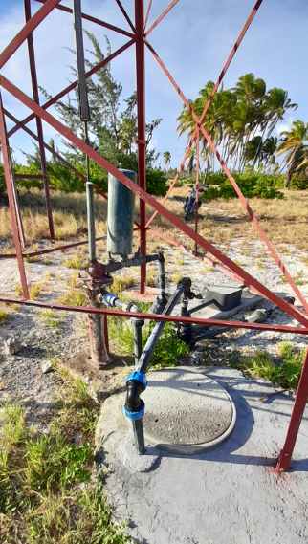
Figure 3. Four Wells gallery 3 West

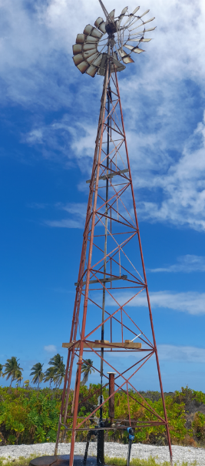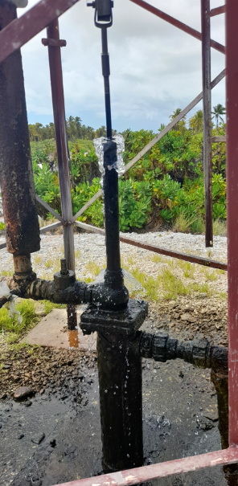
Figure 4. Banana gallery 1 West

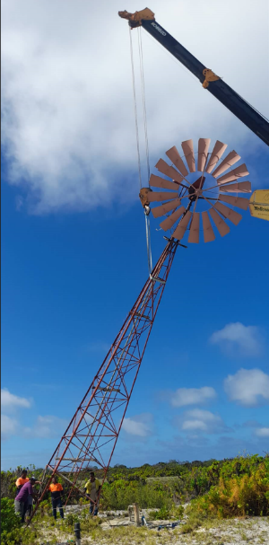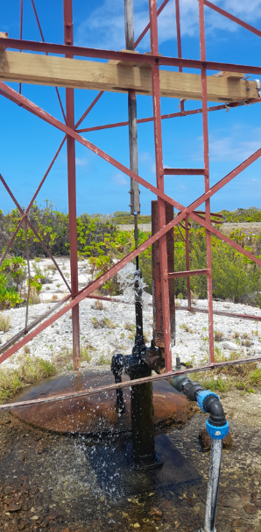
Figure 5. Banana gallery 1 East

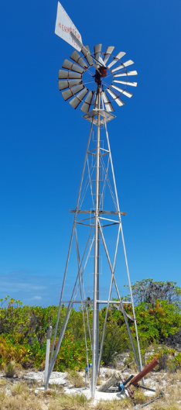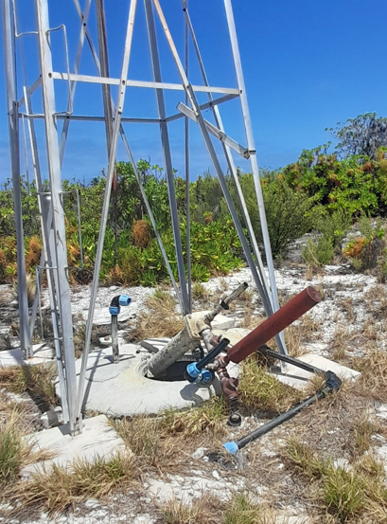
Figure 6. Banana gallery 3 West

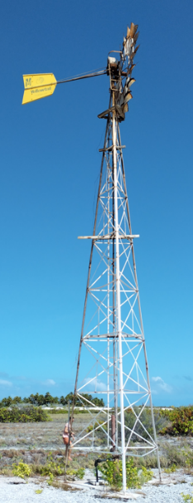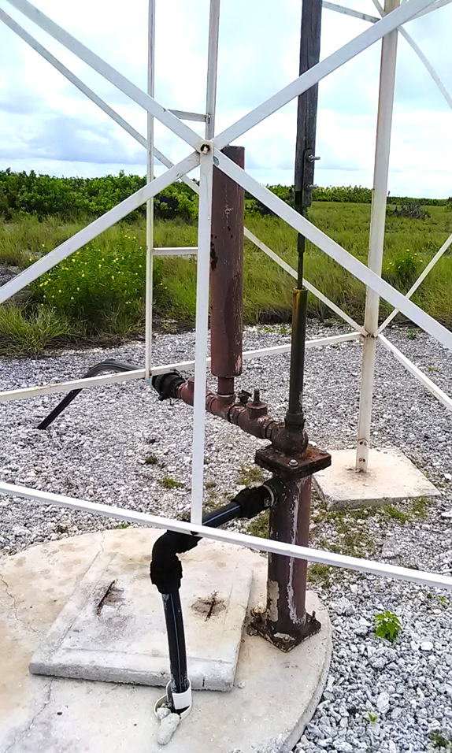
Figure 7. NZ Airfield gallery 1 East

Scope of goods and services required
SPC and MLPID require provision of wind pump parts and technical assistance to achieve the scope as per Table 1Table 1. Summary of Kiritimati wind pump works required. This will involve shipping the required parts to Kiritimati Island (container ships land at Kiritimati port every three to four months) and providing a qualified wind pump technician to travel to Kiritimati for two weeks to support MLPID with installation and rehabilitation works, while training applicable staff on appropriate operations and maintenance (O&M) protocol.

List of goods
Below is a list of all wind pump items to be supplied.
Table 2. Wind pump materials
# | Item | Unit | Quantity
 | 1. Southern Cross sub-assemblies
1.01 | 30ft high 3-post hot-dip galvanised tower to suit a 10ft Southern Cross Windmill, with anchors, ladder and safety platform | set | 1
1.02 | 10ft Southern Cross windmill 3-post (gearbox, wheel, tail and stub tower) with hot-dipped GI fan blades and brackets | set | 1
1.03 | 30ft tower connecting drive rods with cross guides and forks | set | 2
 | 2. Yellowtail sub-assemblies
2.01 | Yellowtail complete 10ft windwheel with hot-dipped GI fan blades and brackets | set | 4
2.02 | Yellowtail 40ft tower connecting drive rods with cross guides and forks | set | 6
 | 3. Gearbox Parts
3.01 | White metal bearings for Yellowtail 10ft gearbox (set of 4) | set | 2
3.02 | Crosshead spindle for Yellowtail 10ft gearbox | ea | 2
3.03 | Shell Omala 150 Oil - 20L drum | drum | 4
 | 4. Tower parts
4.01 | 3 anchor posts, 6 anchor plates HDGI (50/50/5 angle iron) with SS bolts, compatible with 27ft Aermotor tower | set | 1
4.02 | Furling pull-out wire rope with grips, SS, 3 - 4mm x 13m | length | 9
4.03 | Pull-out/furl handle for Yellowtail tower | ea | 2
4.04 | Cold galvanised paint, brushable, for tower and windwheel, 4L | tin | 9
4.05 | SS bolt with nut for Yellowtail tower (M10) | ea | 100
 | 5. Pumping sub-assemblies
5.01 | 3” x 12” stroke cast iron syphon pump, with brass pump and 1-3/8" x 12" compensator, with SS baseplate bolts | set | 5
5.02 | Intake: 2" foot valve F, 2 x 2" x 50mm PE M adaptor, 2" PE elbow, 2" PE pipe for up to 4m deep setting | set | 6
5.03 | Outlet: 2" plastic air chamber with 2 x 2" horizontal check valves, 2" tee with 3/4" offtake, 2" nipples | set | 6
 | 6. Pump parts
6.01 | 1-3/8” x 12” stroke brass compensator complete | set | 2
6.02 | 1-3/8" leather compensator buckets | pair | 45
6.03 | 3" leather pump buckets | pair | 30
6.04 | White compensator rod centralizing bush | ea | 10

Functional specifications
All pump parts will be required to contribute to improved wind pump performance on Kiritimati Island in terms of flow rate, reliability and longevity. Kiritimati has an excellent wind resource with consistent Easterly trade winds throughout the year (especially during La Nina-induced dry periods), and pumps should be capable of pumping on average ≥15kL/d during these periods.

Design and technical specifications
Please complete both tables in Annex 4: Technical Proposal Submission Form. In the second table (see excel file included as an Annex to the Technical Specifications), please enter any information about the proposed goods including any variations to the description provided.
- All Yellowtail and Southern Cross parts should be genuine.
- All other items must be of high quality to cater for long-term and regular use in Kiritimati’s warm, salty and highly corrosive environment.
- AS/NZS certification applies to all applicable items.

Technical assistance
An experienced wind pump technical advisor will be expected to travel to Kiritimati for two weeks to assist SPC and MLPID with the wind pump installation, rehabilitation and O&M training activities. The TA will work closely with WSD staff responsible for wind pump maintenance and perform practical on-the-job training with them and prepare a contextually appropriate Wind Pump Asset Management and Maintenance Plan with them (SPC will assist with convening and facilitating these engagements).

Delivery requirements
The supplier will be responsible for delivering all items to Kiritimati Island port in Kiribati. SPC will facilitate customs clearance and pay associated destination charges.
Delivery should be as soon as possible, though no longer than seven months from contract signing. Ships normally travel to Kiritimati Island once every three to four months.
Delivery costs are to include shipping, export charges, insurance and other associated freight expenses to deliver to Kiritimati Island port.
Items are to be packed and clearly labelled with contents.

Warranty requirements
The bidders should clearly state the warranty period for the items with a minimum being the factory warranty.

Reporting and travel arrangements
The supplier will provide all necessary transport documents (bill of lading, packing list, insurance certificate, etc.) as soon as they are available.
AS/NZS certifications for applicable items must also be provided prior to shipping.
The Technical Advisor (TA) travelling to Kiritimati will work under the direct supervision of SPC’s Project Coordinator, Safe and Sustainable Drinking Water for Kiritimati Island Project.
The TA will be expected to travel to Kiritimati no more than six weeks after pump parts are cleared from the Kiritimati port (items can normally be cleared 2 to 3 weeks after ship arrival). Travel costs, accommodation, and meals will be covered by SPC as per the SPC Travel Policy (do not include travel expenses in your financial proposal). As of April 2023, the per diem for Kiritimati Island was AU$200 per day.
Expenses associated with provision of wind pump installation, operation, maintenance and training materials (additional to those listed in Table 2. Wind pump materials) should be included in the financial proposal.

Skills and qualifications
Bidders are required to provide a brief (maximum 2 pages) proposal highlighting the:
- Key activities and dates proposed to deliver the goods and services outlined in the Specification of Goods; and
- Intended approach and methodology to support installation, rehabilitation, operations, maintenance and technical training activities on-island.

Bidders are also required to provide a brief proposal (using the template in Annex 4) highlighting compliance, knowledge, skills and previous experience in the following areas and attributes.
Organisational requirements for the provision of goods:
- Evidence of at least 10 years’ practical experience in supply of wind pumps and parts (at least 2 contracts; contracts with SPC should also be included).
- Compliance with functional requirements as stated in the Specification of Goods, including compatibility, availability, brand, quality and origin of goods.
- Compliance with design and technical requirements as stated in the Specification of Goods.
- Experience shipping goods in the Pacific and capacity to deliver items within 7 months.

Technical advisor (TA) requirements for provision of technical assistance services on-island:
- At least 15 years practical experience in wind pump parts and service provision, especially of Yellowtail, Southern Cross and Aermotor make.
- Experience working with and effectively building technical and operational capacity of water supply authorities.

Scope of bid price and schedule of payments
The value of the contract will be based on milestones/outputs outlined in the table below.
The terms of payment shall be in accordance with the provisions of Article 10 of the SPC General Conditions.

# | Milestone/Output | % Payment
1 | Signing of contract | 10%
2 | Submission of freighting documents and applicable certifications | 20%
3 | Delivery, quality check and acceptance of goods on Kiritimati Island | 40%
4 | Technical assistance (2-weeks on-island) supporting wind pump installation, rehabilitation, operation, maintenance and training, including preparation of a contextually appropriate Wind Pump Asset Management and Maintenance Plan for Kiritimati Island with key stakeholders | 30%
 | TOTAL | 100%

Annexes to the Specification of Goods
- Annex to Specification of Goods – BoQ and supporting info

Part 4: PROPOSAL EVALUATION MATRIX

4.1 Competency Requirements & Score Weight
A two-stage procedure will be utilised to evaluate the proposals, with evaluation of the technical proposal being completed prior to any financial proposal being opened and compared.
The competencies which will be evaluated are detailed in Part 3.
The evaluation matrix bellow also reflects the obtainable score specified for each evaluation criterion (technical requirement) which indicates the relative significance or weight of the items in the overall evaluation process.
The technical component, which has a total possible value of 700 points, will be evaluated using the following criteria:

Competency Requirements | Score Weight  (%) | Points obtainable
Mandatory requirements
E-mail 1 (technical submission):  - The bidder will need to attach a brief (maximum 2 pages) work schedule summarising:  - the key activities and dates proposed to deliver the goods and services outlined in the Specification of Goods; and  - proposed approach to providing the necessary technical assistance and training.  - Letter of application (Annex 1)  - Conflict of interest declaration (Annex 2)  - Completed Information about the bidder and due diligence form (Annex 3)  - Technical proposal submission Form (Annex 4)  - CV of Technical Advisor nominated to travel to Kiritimati Island  E-mail 2 (financial submission; password protected):  - Financial proposal submission for (Annex 5) | Mandatory requirements. Bidders will be disqualified if these requirements are not met
Organisational and delivery requirements
Supply experience | 20% | 140
Evidence of at least 10 years’ practical experience in supply of similar items (at least 2 contracts; contracts with SPC should also be included).

Functional | 15% | 105
Compliance with functional requirements as stated in the Specification of Goods, including compatibility, availability, brand, quality and origin of goods.
Design and technical | 15% | 105
Compliance with design and technical requirements as stated in the Specification of Goods
Delivery | 10% | 70
Experience shipping goods in the Pacific and capacity to deliver items within 7 months.
Technical advisor requirements
Practical experience | 30% | 210
At least 15 years practical experience in wind pump parts and service provision, especially of Yellowtail, Southern Cross and Aermotor make.
Capacity building | 10% | 70
Experience working with and effectively building technical and operational capacity of water supply authorities.
Total Score | 100% | 700
Qualification score | 70% | 490

4.2 Financial evaluation
The financial component of the proposal will be scored on the basis of overall costs for the delivery of the goods and financial incentives and benefits provided to SPC. The lowest financial proposal will be awarded maximum 300 points and other financial offers and incentives will be awarded points as per the formula below:
Financial Proposal score = (Lowest Price / Price under consideration) x 300

RFP 23-5381

Part 5: PROPOSAL SUBMISSION FORMS

Annex 1: BIDDER’S LETTER OF APPLICATION
Dear Sir /Madam:
Having examined the Solicitation Documents, the receipt of which is hereby duly acknowledged, we the undersigned, offer to supply the required goods for the sum as may be ascertained in accordance with the Financial Proposal attached herewith and made part of this proposal.
We acknowledge that:
- SPC may exercise any of its rights set out in the Request for Proposal documents, at any time;
- The statements, opinions, projections, forecasts or other information contained in the Request for Proposal documents may change;
- The Request for Proposal documents are a summary only of SPC’s requirements and is not intended to be a comprehensive description of them;
- Neither the lodgement of the Request for Proposal documents nor the acceptance of any tender nor any agreement made subsequent to the Request for Proposal documents will imply any representation from or on behalf of SPC that there has been no material change since the date of the Request for Proposal documents, or since the date as at which any information contained in the Request for Proposal documents is stated to be applicable;
- Excepted as required by law and only to the extent so required, neither SPC, nor its respective officers, employees, advisers or agents will in any way be liable to any person or body for any loss, damage, cost or expense of any nature arising in any way out of or in connection with any representations, opinions, projections, forecasts or other statements, actual or implied, contained in or omitted from the Request for Proposal documents.
We undertake, if our proposal is accepted, to commence and complete delivery of all items in the contract within the time frame stipulated.
We understand that you are not bound to accept any proposal you may receive and that a binding contract would result only after final negotiations are concluded on the basis of the Technical and Financial Components proposed.

For the Bidder: [insert name of the company]

Signature:

Name of the Bidder’s representative: [insert name of the representative]
Title: [insert Title of the representative]
Date: [Click or tap to enter a date]

RFP 23-5381

Annex 2: CONFLICT OF INTEREST DECLARATION

INSTRUCTIONS TO BIDDERS

What is a conflict of interest?
A conflict of interest may arise from economic or commercial interests, political, trade union or national affinities, family, cultural or sentimental ties, or any other type of relationship or common interest between the bidder and any person connected with the contracting authority (SPC staff member, consultant or any other expert or collaborator mandated by SPC).

Always declare a conflict
The existence of a potential or apparent conflict of interest does not necessarily prevent the bidder concerned from taking part in a tender process. However, the declaration of the existence of such a conflict by the persons concerned is essential and allows SPC to take appropriate measures to mitigate it and prevent the associated risks.
Bidders are therefore invited to declare any situation, fact or link which, to their knowledge, could generate a real, potential or apparent conflict of interest.

Declaration at any time
Conflicts of interest may arise at any time during the procurement process or the implementation of a contract (e.g. new partner in the project) or as a result of a change in personal life (e.g. marriage, inheritance, financial transaction, creation of a company). If such a relationship is found and could be perceived by a reasonable person as likely to influence a decision, a declaration of the situation is necessary. In case of doubt, a conflict situation must be declared.

Declaration for any person involved
A declaration must be completed for each person involved in the tender (principal representative of the bidder, possible subcontractors, consultant, etc.)

Failure
Failing to declare a potential conflict of interest may result in the bidder being refused a contract or placed on SPC's list of non-responsible suppliers.

RFP 23-5381

DECLARATION
I, the undersigned, [name of the representative of the Bidder], acting in the name and on behalf of the company [name of the company], declare that:
☐ | To my knowledge, I am not in a conflict-of-interest situation
☐ | There is a potential conflict of interest with regard to my Choose an item. relationship with [name of the person concerned] in his or her capacity as [position/role/personal or family link with the person concerned], although, to the best of my knowledge, this person is not directly or indirectly involved in any stage of the procurement process
☐ | I may be in a conflict of interest with regard to my Choose an item relationship with [name of the person concerned] in his or her capacity as [position/role/personal or family link with the person concerned], as this person is, to the best of my knowledge, directly or indirectly linked to the procurement process
☐ | To my knowledge, there is another situation that could potentially constitute a conflict of interest:  [Describe the situation that may constitute a conflict of interest]
In addition, I undertake to:
- declare, without delay, to SPC any situation that constitutes a potential conflict of interest or is likely to lead to a conflict-of-interest;
- not to grant, seek, obtain or accept any advantage, whether financial or in kind, to or from any person where such advantage constitutes an unfair practice or an attempt at fraud or corruption, directly or indirectly, or constitutes a gratuity or reward related to the award of the contract;
- to provide accurate, truthful and complete information to SPC in connection with this procurement process.
I acknowledge that I and/or my company and/or my business partners who are jointly and severally bidding on the RFP [SPC Reference] may be subject to sanctions such as being placed on SPC's list of non-responsible vendors, if it is established that false statements have been made or false information has been provided.
For the Bidder: [insert name of the company]

Signature:

Name of the Bidder’s representative: [insert name of the representative]
Title: [insert Title of the representative]
Date: [Click or tap to enter a date]

RFP 23-5381

Annex 3: INFORMATION ABOUT THE BIDDER AND DUE DILIGENCE
Please complete the following questionnaire and provide supporting documents where applicable.

VENDOR INFORMATION
Are you already registered as an SPC vendor? |  |  |  |  |  |  | ☐ Yes | ☐ No
If ‘No’, please complete the form. If ‘Yes’, do you have any information to update? |  |  |  |  |  |  | ☐ Yes | ☐ No
If ‘Yes’, please complete the form. If ‘No’, sign directly the form without completing it
- Please provide information related to your entity.
Company name | [Enter company name] |  |  | Address | [Enter address]
Director/CEO | [Enter name of the executive person] |  |  | Position | [Enter position of the executive person]
Business Registration/License number |  | [Enter company registration/license number (or tax number)]
Date of business registration |  | [Enter date of business registration]
Country of business registration |  | [Enter country of business registration]
Status of the entity:
☐ For-profit entity (company), ☐ NGO, ☐ International organisation,
☐ Government body, ☐ University, ☐ Association, ☐ Research Institute, ☐ Other: [insert details]
- Please provide the following documents (or any other relevant documents according to your national legislation) to verify the legal existence of the entity, the authority of its officer and proof of its address:
☐ Evidence of the power of attorney or board resolution granted to the officer to transact business on its behalf or any other document delegating authority
☐ Certificate of business registration/license
☐ Memorandum, Articles or Statutes of Association
☐ Telephone or electricity bill in the name of the entity
☐ Bank statement bearing the name of the entity
- How many employees does your company and its subsidiaries have? |  |  |  |  |  | [provide answer]
- Do you have professional insurance against all risks in respect of your employees, sub-contractors, property and equipment? |  |  |  |  |  |  | ☐ Yes | ☐ No
- If ‘no’, what type of business insurance do you have? |  |  |  | [provide answer]
- Are you up to date with your tax and social security payment obligations? |  |  |  |  |  |  | ☐ Yes | ☐ No
- Is your entity regulated by a national authority? |  |  |  |  |  |  | ☐ Yes | ☐ No
If you answered ‘yes’, please specify the name: |  |  | [Insert name of the national regulation authority]
- Is your entity a publicly held company? |  |  |  |  |  |  | ☐ Yes | ☐ No
- Does your entity have a publicly available annual report? |  |  |  |  |  |  | ☐ Yes | ☐ No
Please send SPC your audited financial statement from the last 3 financial years if available

DUE DILIGENCE
- Does your entity have foreign branches and/or subsidiaries? |  |  |  |  |  |  |  | ☐ Yes |  | ☐ No
If you answered ‘yes’ to the previous question, please confirm the branches.
- Head Office & domestic branches |  |  |  |  |  |  |  | ☐ Yes | ☐ No
- Domestic subsidiaries |  |  |  |  |  |  |  | ☐ Yes | ☐ No
- Overseas branches |  |  |  |  |  |  |  | ☐ Yes | ☐ No
- Overseas subsidiaries |  |  |  |  |  |  |  | ☐ Yes | ☐ No
- Does your entity provide financial services to customers determined to be high risk including but not limited to:
Foreign Financial Institutions | ☐ Yes | ☐ No |  |  |  | Casinos |  | ☐ Yes | ☐ No
Cash Intensive Businesses | ☐ Yes | ☐ No |  |  |  | Foreign Government Entities |  | ☐ Yes | ☐ No
Non-Resident Individuals | ☐ Yes | ☐ No |  |  |  | Money Service Businesses |  | ☐ Yes | ☐ No
☐ Other, please provide details: |  |  |  |  |  | [Provide details]
- If you answered ‘yes’ to any of the boxes in question 11, does your entity’s policies and procedures specifically outline how to mitigate the potential risks associated with these higher risk customer types? |  |  |  |  |  |  |  | ☐ Yes | ☐ No
If you answered ‘yes’, please explain how: |  |  | [Provide explanation]
- Does your entity have a written policy, controls and procedures reasonably designed to prevent and detect fraud, corruption, money laundering or terrorist financing activities? |  |  |  |  |  |  |  | ☐ Yes | ☐ No
If ‘yes’, please send SPC your policy in English.
- Does your entity have an officer responsible for anti-corruption, or anti-money laundering and counter-terrorism financing policy? |  |  |  |  |  |  |  | ☐ Yes | ☐ No
If yes, please state that officer’s contact details: |  |  |  |  | [Insert name and contact details of your officer in charge]
If ‘no’, what process does your entity have in place to prevent and detect money laundering or terrorist financing activities? |  |  |  |  |  |  | [provide answer]
- Has your entity or any affiliated entity ever filed for bankruptcy? |  |  |  |  |  |  |  | ☐ Yes | ☐ No
- Have any of the entity’s current or former directors or CEO filed for bankruptcy? |  |  |  |  |  |  |  | ☐ Yes | ☐ No
- Has your entity ever been the subject of any investigations or had any regulatory or criminal enforcement actions resulting from violations of any laws or regulations, including those relating to money laundering or terrorism financing? |  |  |  |  |  |  |  | ☐ Yes | ☐ No
If you answered ‘yes’, please provide details: |  |  |  | [Provide details]
- Has the director or CEO of your entity ever been the subject of any investigations or had any regulatory or criminal enforcement actions resulting from violations of any laws or regulations, including those relating to money laundering or terrorism financing? |  |  |  |  |  |  |  | ☐ Yes | ☐ No
If you answered ‘yes’, please provide details: |  |  |  | [Provide details]

SOCIAL AND ENVIRONMENTAL RESPONSIBILITY (SER)
- Does your entity have a written policy, controls and procedures to implement its Social and Environmental Responsibility (SER) commitments? |  |  |  | ☐ Yes | ☐ No
If yes, please send SPC your policy in English.
Does your Policy cover the followings?
☐ Child protection ☐ Human rights ☐ Gender equality ☐ Social inclusion
☐ Sexual harassment, abuse or exploitation ☐ Environmental responsibility
Please, outline the major actions you have undertaken in these areas: | [provide answer]
- Does your entity have an officer responsible for Social and Environmental Responsibility (SER)? |  |  |  | ☐ Yes | ☐ No
If yes, please state that officer’s contact details: |  | [Insert name and contact details of your officer in charge]
If ‘no’, what process does your entity have in place to ensure your social and environmental responsibility? |  |  | [provide answer]

I declare that the particulars given herein above are true, correct and complete to the best of my knowledge, and the documents submitted in support of this form are genuine and obtained legally from the respective issuing authority.
I declare that none of the funds received or to be received by my company will be used for criminal activities, including financing terrorism or money laundering.
By sending this declaration to SPC, I agree that my business and personal information may be used by SPC for due diligence purposes. I also understand and accept that SPC will treat any personal information it receives in connection with my proposal in accordance with its Privacy Policy, and the Guidelines for handling personal information of bidders and grantees.

For the Bidder: [insert name of the company]

Signature:

Name of the Bidder’s representative: [insert name of the representative]
Title: [insert Title of the representative]
Date: [Click or tap to enter a date]

RFP 23-5381

Annex 4: TECHNICAL PROPOSAL SUBMISSION FORM

INSTRUCTIONS TO BIDDERS
Please complete both tables below to support technical evaluation of bids.

Technical Requirements
Mandaotory Requirements | Response by Bidder
E-mail 1 (technical submission)
Schedule & methodology: Please attach a brief (maximum 2 pages) work schedule summarising (i) the key activities and dates proposed to deliver the goods and services outlined in the Specification of Goods; and (ii) methodology to provide necessary technical assistance and training. | Check if submitted with the technical proposal
Letter of application: Annex 1 | Check if submitted with the technical proposal
Conflict of interest declaration: Annex 2 | Check if submitted with the technical proposal
Completed information about the bidder and due diligence form: Annex 3 | Check if submitted with the technical proposal
Technical proposal submission Form: Annex 4 | Check if submitted with the technical proposal
E-mail 2 (financial submission – password protected)
Financial proposal submission: Annex 5 | Check if password protected and submitted separately
Organisational and delivery requirements
Supply experience
Evidence of at least 10 years’ practical experience in supply of similar items (at least 2 contracts; contracts with SPC should also be included) (20%) | [Bidder’s answer]
Functional
Compliance with functional requirements as stated in the Specification of Goods, including compatibility, availability, brand, quality and origin of goods (15%) | [Bidder’s answer]
Design and technical
Compliance with design and technical requirements as stated in the Specification of Goods (15%) | [Bidder’s answer]
Delivery
Experience shipping goods in the Pacific and capacity to deliver items within 7 months (10%) | [Bidder’s answer]
Technical advisor requirements
Practical experience
At least 15 years practical experience in wind pump parts and service provision, especially of Yellowtail, Southern Cross and Aermotor make. (30%) | [Bidder’s answer]
Capacity building
Experience working with and effectively building technical and operational capacity of water supply authorities (10%) | [Bidder’s answer]

Please complete the right-hand columns in the technical specifications table below.

# | Item | Unit | Quantity | Responses by Bidder
 |  |  |  | State whether:  i) Fully compliant;  ii) Partially compliant; or  iii) Not compliant.  Bidder to state reason why specs offered are partially or not compliant. Minor deviations are acceptable. | Please enter brand name, plus info about availability, model, quality, specs, etc.
1. Southern Cross sub-assemblies
1.01 | 30ft high 3-post hot-dip galvanised tower to suit a 10ft Southern Cross Windmill, with anchors, ladder and safety platform | set | 1
1.02 | 10ft Southern Cross windmill 3-post (gearbox, wheel, tail and stub tower) with hot-dipped GI fan blades and brackets | set | 1
1.03 | 30ft tower connecting drive rods with cross guides and forks | set | 2
2. Yellowtail sub-assemblies
2.01 | Yellowtail complete 10ft windwheel with hot-dipped GI fan blades and brackets | set | 4
2.02 | Yellowtail 40ft tower connecting drive rods with cross guides and forks | set | 6
3. Gearbox Parts
3.01 | White metal bearings for Yellowtail 10ft gearbox (set of 4) | set | 2
3.02 | Crosshead spindle for Yellowtail 10ft gearbox | ea | 2
3.03 | Shell Omala 150 Oil - 20L drum | drum | 4
4. Tower parts
4.01 | 3 anchor posts, 6 anchor plates HDGI (50/50/5 angle iron) with SS bolts, compatible with 27ft Aermotor tower | set | 1
4.02 | Furling pull-out wire rope with grips, SS, 3 - 4mm x 13m | length | 9
4.03 | Pull-out/furl handle for Yellowtail tower | ea | 2
4.04 | Cold galvanised paint, brushable, for tower and windwheel, 4L | tin | 9
4.05 | SS bolt with nut for Yellowtail tower (M10) | ea | 100
5. Pumping sub-assemblies
5.01 | 3” x 12” stroke cast iron syphon pump, with brass pump and 1-3/8" x 12" compensator, with SS baseplate bolts | set | 5
5.02 | Intake: 2" foot valve F, 2 x 2" x 50mm PE M adaptor, 2" PE elbow, 2" PE pipe for up to 4m deep setting | set | 6
5.03 | Outlet: 2" plastic air chamber with 2 x 2" horizontal check valves, 2" tee with 3/4" offtake, 2" nipples | set | 6
6. Pump parts
6.01 | 1-3/8” x 12” stroke brass compensator complete | set | 2
6.02 | 1-3/8" leather compensator buckets | pair | 45
6.03 | 3" leather pump buckets | pair | 30
6.04 | White compensator rod centralizing bush | ea | 10

For the Bidder: [insert name of the company]

Signature:

Name of the Bidder’s representative: [insert name of the representative]
Title: [insert Title of the representative]
Date: [Click or tap to enter a date]

RFP 23-5381

Annex 5: FINANCIAL PROPOSAL SUBMISSION FORM
- All costs indicated on the Financial Proposal should be exclusive of all applicable taxes.
- Please use the template provided below.
- You must submit this Financial Proposal in a separate email to the technical proposal. All prices in the proposal must be presented in AUD. Your Financial Proposal is to be password protected. SPC will request the password in the event that it is required.
FINANCIAL PRPOPOSAL SUMMARY TABLE
Item | Unit | Quantity | Cost [AUD]
GOODS
1. Southern Cross sub-assemblies |  |  | $
30ft high 3-post hot-dip galvanised tower to suit a 10ft Southern Cross Windmill, with anchors, ladder and safety platform | set | 1 | $
10ft Southern Cross windmill 3-post (gearbox, wheel, tail and stub tower) with hot-dipped GI fan blades and brackets | set | 1 | $
30ft tower connecting drive rods with cross guides and forks | set | 2 | $
2. Yellowtail sub-assemblies |  |  | $
Yellowtail complete 10ft windwheel with hot-dipped GI fan blades and brackets | set | 4 | $
Yellowtail 40ft tower connecting drive rods with cross guides and forks | set | 6
3. Gearbox Parts |  |  | $
White metal bearings for Yellowtail 10ft gearbox (set of 4) | set | 2 | $
Crosshead spindle for Yellowtail 10ft gearbox | ea | 2 | $
Shell Omala 150 Oil - 20L drum | drum | 4 | $
4. Tower parts |  |  | $
3 anchor posts, 6 anchor plates HDGI (50/50/5 angle iron) with SS bolts, compatible with 27ft Aermotor tower | set | 1 | $
Furling pull-out wire rope with grips, SS, 3 - 4mm x 13m | length | 9 | $
Pull-out/furl handle for Yellowtail tower | ea | 2 | $
Cold galvanised paint, brushable, for tower and windwheel, 4L | tin | 9 | $
SS bolt with nut for Yellowtail tower (M10) | ea | 100 | $
5. Pumping sub-assemblies |  |  | $
3” x 12” stroke cast iron syphon pump, with brass pump and 1-3/8" x 12" compensator, with SS baseplate bolts | set | 5 | $
Intake: 2" foot valve F, 2 x 2" x 50mm PE M adaptor, 2" PE elbow, 2" PE pipe for up to 4m deep setting | set | 6 | $
Outlet: 2" plastic air chamber with 2 x 2" horizontal check valves, 2" tee with 3/4" offtake, 2" nipples | set | 6 | $
6. Pump parts |  |  | $
1-3/8” x 12” stroke brass compensator complete | set | 2 | $
1-3/8" leather compensator buckets | pair | 45 | $
3" leather pump buckets | pair | 30 | $
White compensator rod centralizing bush | ea | 10 | $
SUB-TOTAL GOODS |  |  | $
SERVICES
Professional fees for Technical Advisor’s 2-week trip to Kiritimati* | lump | 1 | $
Other related costs (if any, please specify) |  |  | $
SUB-TOTAL SERVICES |  |  | $
TOTAL GOODS & SERVICES |  |  | $

* Travel costs, accommodation, and meals will be covered by SPC as per the SPC Travel Policy (do not include travel expenses in your financial proposal). As of April 2023, the per diem for Kiritimati Island was AU$200 per day.
No payment will be made for items which have not been priced. Such items are deemed to be covered by the financial offer. Bidders will be deemed to have satisfied themselves, before submitting their proposal, considering all that is required for the full and proper performance of the contract and to have included all applicable costs in their rates and prices.

For the Bidder: [insert name of the company]

Signature:

Name of the Bidder’s representative: [insert name of the representative]

Title: [insert Title of the representative]
Date: [Click or tap to enter a date]

At the time of writing (April 2023), commercial flights to/from Kiritimati have yet to resume since 2020 due to COVID and then airport compliance issues. It is expected the Nadi – Kiritimati – Honolulu (NAN-CXI-HNL) weekly flights will resume by May/June 2023.

