**EOI 23-5692**

EXPRESSION OF INTEREST (EOI)

**Tender Invitation elements**

|  |  |
| --- | --- |
| **Project Title:** | **FAME RESEARCH VESSEL** |
| **Nature of the** services | Build a fisheries research vessel for the Pacific Community |
| **Location:** | Pacific Region |
| **Date of issue:** | 11/09/2023 |
| **Closing Date:** | 6/11/2023 |
| **SPC Reference:** | 23-5692 |

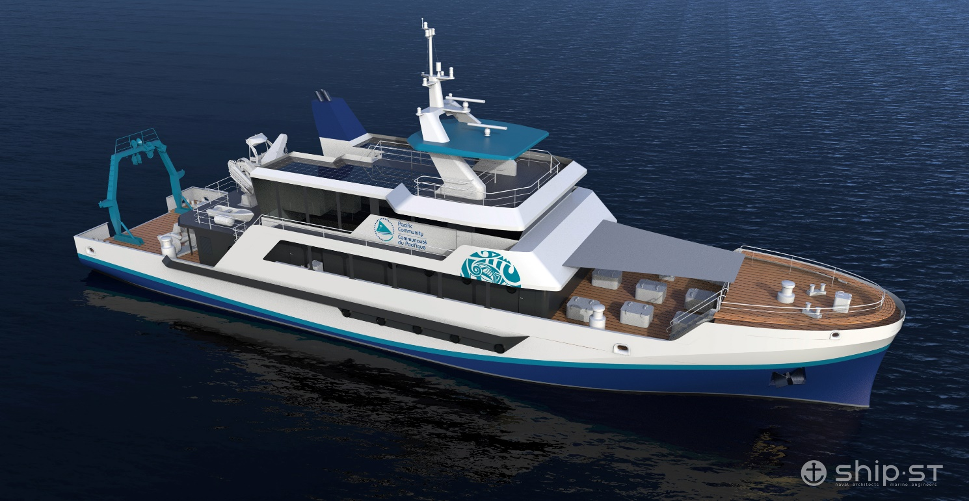

**EOI 23-5692**

# Part 5: PROPOSAL SUBMISSION FORMS

# Annex 1: BIDDER’S LETTER OF APPLICATION

Dear Sir /Madam:

Having examined the Solicitation Documents, the receipt of which is hereby duly acknowledged, we the undersigned, wish to confirm our interest in the next RFP in the context of the construction of the FAME research vessel.

We acknowledge that:

* SPC may exercise any of its rights set out in the EOI documents, at any time;
* The statements, opinions, projections, forecasts or other information contained in the EOI documents may change;
* The EOI documents are a summary only of SPC’s requirements and is not intended to be a comprehensive description of them;
* Neither the lodgement of the EOI documents nor the acceptance of any tender nor any agreement made subsequent to the EOI documents will imply any representation from or on behalf of SPC that there has been no material change since the date of the EOI documents, or since the date as at which any information contained in the EOI documents is stated to be applicable;
* Excepted as required by law and only to the extent so required, neither SPC, nor its respective officers, employees, advisers or agents will in any way be liable to any person or body for any loss, damage, cost or expense of any nature arising in any way out of or in connection with any representations, opinions, projections, forecasts or other statements, actual or implied, contained in or omitted from the EOI documents.

We understand that you are not bound to accept any proposal you may receive and that a solicitation for the upcoming RFP would result only after final evaluations and approval of the proposal.

|  |
| --- |
| **For the Bidder:** *[insert name of the company]* |
| Signature:  Name of the Bidder’s representative: *[insert name of the representative]*  Title: *[insert Title of the representative]* |
| Date: *[Click or tap to enter a date]* |

# Annex 2: CONFLICT OF INTEREST DECLARATION

##### **INSTRUCTIONS TO BIDDERS**

What is a conflict of interest?

A conflict of interest may arise from economic or commercial interests, political, trade union or national affinities, family, cultural or sentimental ties, or **any other type of relationship or common interest between the bidder and any person connected with the contracting authority** (SPC staff member, consultant or any other expert or collaborator mandated by SPC).

Always declare a conflict

The existence of a potential or apparent conflict of interest does not necessarily prevent the bidder concerned from taking part in a tender process. **However, the declaration of the existence of such a conflict by the persons concerned is essential and allows SPC to take appropriate measures to mitigate it and prevent the associated risks.**

Bidders are therefore invited to declare any situation, fact or link which, to their knowledge, could generate a real, potential or apparent conflict of interest.

Declaration at any time

Conflicts of interest may arise at any time during the procurement process or the implementation of a contract (e.g. new partner in the project) or as a result of a change in personal life (e.g. marriage, inheritance, financial transaction, creation of a company). If such a relationship is found and could be perceived by a reasonable person as likely to influence a decision, a declaration of the situation is necessary. In case of doubt, a conflict situation must be declared.

Declaration for any person involved

A declaration must be completed for each person involved in the tender (principal representative of the bidder, possible subcontractors, consultant, etc.)

Failure

Failing to declare a potential conflict of interest may result in the bidder being refused a contract or placed on SPC's list of non-responsible suppliers.

**EOI 23-5692**

##### **DECLARATION**

I, the undersigned, *[name of the representative of the Bidder]*, acting in the name and on behalf of the company *[name of the company]*, declare that:

|  |  |
| --- | --- |
|  | To my knowledge, I am not in a conflict-of-interest situation |
|  | There is a potential conflict of interest with regard to my *[Choose an item]*. relationship with *[name of the person concerned]* in his or her capacity as [*position/role/personal or family link with the person concerned]*, although, to the best of my knowledge, this person is not directly or indirectly involved in any stage of the procurement process |
|  | I may be in a conflict of interest with regard to my *[Choose an item]* relationship with *[name of the person concerned]* in his or her capacity as [*position/role/personal or family link with the person concerned]*, as this person is, to the best of my knowledge, directly or indirectly linked to the procurement process |
|  | To my knowledge, there is another situation that could potentially constitute a conflict of interest:  *[Describe the situation that may constitute a conflict of interest]* |

In addition, I undertake to:

* declare, without delay, to SPC any situation that constitutes a potential conflict of interest or is likely to lead to a conflict-of-interest;
* not to grant, seek, obtain or accept any advantage, whether financial or in kind, to or from any person where such advantage constitutes an unfair practice or an attempt at fraud or corruption, directly or indirectly, or constitutes a gratuity or reward related to the award of the contract;
* to provide accurate, truthful and complete information to SPC in connection with this procurement process.

I acknowledge that I and/or my company and/or my business partners who are jointly and severally bidding on the **EOI 23-5692** may be subject to sanctions such as being placed on SPC's list of non-responsible vendors, if it is established that false statements have been made or false information has been provided.

|  |
| --- |
| **For the Bidder:** *[insert name of the company]* |
| Signature:  Name of the representative: *[insert name of the representative]*  Title: *[insert Title of the representative]* |
| Date: *[Click or tap to enter a date]* |

**EOI** **23-5692**

# Annex 3: INFORMATION ABOUT THE BIDDER AND DUE DILIGENCE

Please complete the following questionnaire and provide supporting documents where applicable.

|  |  |  |  |  |  |  |  |  |  |  |
| --- | --- | --- | --- | --- | --- | --- | --- | --- | --- | --- |
| VENDOR INFORMATION | | | | | | | | | | |
| **Are you already registered as an SPC vendor?** | | | | | | | | | Yes | No |
| 1. **Please provide information related to your entity.** | | | | | | | | | | |
| **Company name** | *[Enter company name]* | | | | | **Address** | *[Enter address]* | | | |
| **Director/CEO** | *[Enter name of the executive person]* | | | | | **Position** | *[Enter position of the executive person]* | | | |
| **Business Registration/License number** | | | | *[Enter company registration/license number (or tax number)]* | | | | | | |
| **Date of business registration** | | | | *[Enter date of business registration]* | | | | | | |
| **Country of business registration** | | | | *[Enter country of business registration]* | | | | | | |
| **Status of the entity:**  For-profit entity (company),  NGO,  International organisation,  Government body,  University,  Association,  Research Institute,  Other: *[insert details]* | | | | | | | | | | |
| 1. **Please provide relevant documentation to support and verify the legal existence of the entity, the authority of its officer and proof of its address, such as:** | | | | | | | | | | |
| Delegation of authority or power of attorney document  Certificate of business registration/license  Memorandum, Articles or Statutes of Association  Telephone, water, or electricity bill in the name of the entity  Bank account details bearing the name of the entity | | | | | | | | | | |
| 1. **How many employees does your company and its subsidiaries have?** | | | | | | | | *[provide answer]* | | |
| 1. **Do you have professional insurance against all risks in respect of your employees, sub-contractors, property and equipment?** | | | | | | | | | Yes | No |
| *If ‘No’, what type of business insurance do you have?* | | | | | *[provide answer]* | | | | | |
| 1. **Are you up to date with your tax and social security payment obligations?** | | | | | | | | | Yes | No |
| *If ‘No’, please explain the situation:* | | | *[Provide details]* | | | | | | | |
| 1. **Is your entity regulated by a national authority?** | | | | | | | | | Yes | No |
| *If ‘Yes’, please specify the name:* | | *[Insert name of the national regulation authority]* | | | | | | | | |
| 1. **Is your entity a publicly held company?** | | | | | | | | | Yes | No |
| 1. **Does your entity have a publicly available annual report?** | | | | | | | | | Yes | No |
| *Please send SPC your audited financial statement from the last 3 financial years if available* | | | | | | | | | | |

|  |  |  |  |  |  |  |  |  |  |  |
| --- | --- | --- | --- | --- | --- | --- | --- | --- | --- | --- |
| DUE DILIGENCE | | | | | | | | | | |
| 1. **Does your entity have foreign branches and/or subsidiaries?** | | | | | | | | Yes | | No |
| *If you answered ‘yes’ to the previous question, please confirm the branches:* | | | | | | | | | | |
| * Head Office & domestic branches | | | | | | | | Yes | No | |
| * Domestic subsidiaries | | | | | | | | Yes | No | |
| * Overseas branches | | | | | | | | Yes | No | |
| * Overseas subsidiaries | | | | | | | | Yes | No | |
| 1. **Does your entity provide financial services to customers determined to be high risk including but not limited to:** | | | | | | | | | | |
| Foreign Financial Institutions | Yes | | No | | | Casinos | | Yes | No | |
| Cash Intensive Businesses | Yes | | No | | | Foreign Government Entities | | Yes | No | |
| Non-Resident Individuals | Yes | | No | | | Money Service Businesses | | Yes | No | |
| Other, *please provide details:* | | | | | | *[Provide details]* | | | | |
| 1. **If you answered ‘yes’ to any of the boxes in question 10, does your entity’s policies and procedures specifically outline how to mitigate the potential risks associated with these higher risk customer types?** | | | | | | | | Yes | No | |
| *If ‘Yes’, please explain how:* | | | | *[Provide explanation]* | | | | | | |
| 1. **Does your entity have a written policy, controls and procedures reasonably designed to prevent and detect fraud, corruption, money laundering or terrorist financing activities?** | | | | | | | | Yes | No | |
| *If ‘Yes’, please send SPC your policy in English.* | | | | | | | | | | |
| *If ‘No’, what process does your entity have in place to prevent and detect money laundering or terrorist financing activities?* | | | | | | | *[provide answer]* | | | |
| 1. **Does your entity have an officer responsible for anti-corruption, or anti-money laundering and counter-terrorism financing policy?** | | | | | | | | Yes | No | |
| *If ‘Yes’, please state that officer’s contact details:* | | | | | *[Insert name and contact details]* | | | | | |
| 1. **Has your entity or any of its current or former directors or CEOs ever filed for bankruptcy?** | | | | | | | | Yes | No | |
| *If ‘Yes’, please provide details:* | | *[Provide details]* | | | | | | | | |
| 1. **Has your entity or any of its current or former directors or CEOs ever been the subject of any investigations or had any regulatory or criminal enforcement actions resulting from violations of any laws or regulations, including those relating to money laundering or terrorism financing?** | | | | | | | | Yes | No | |
| *If ‘Yes’, please provide details:* | | *[Provide details]* | | | | | | | | |

|  |  |  |  |  |  |
| --- | --- | --- | --- | --- | --- |
| SOCIAL AND ENVIRONMENTAL RESPONSIBILITY (SER) | | | | | |
| 1. **Does your entity have a written policy, controls and procedures to implement its Social and Environmental Responsibility (SER) commitments?** | | | | Yes | No |
| *If ‘Yes’, please send SPC your policy in English.* | | | | | |
| *If ‘No’, what process does your entity have in place to ensure your social and environmental responsibility?* | | | *[provide answer]* | | |
| **Does your Policy or Process cover the followings?**  Child protection  Human rights  Gender equality  Social inclusion  Sexual harassment, abuse or exploitation  Environmental responsibility | | | | | |
| *Please, outline the major actions you have undertaken in these areas:* | *[provide answer]* | | | | |
| 1. **Does your entity have an officer responsible for Social and Environmental Responsibility (SER)?** | | | | Yes | No |
| *If ‘Yes’, please state that officer’s contact details:* | | *[Insert name and contact details]* | | | |

|  |  |
| --- | --- |
| SUPPORTING DOCUMENTS (where relevant) | |
| * Business registration/license proof |  |
| * Bank account details document |  |
| * Address of the entity and Authority of officer proofs |  |
| * Audited financial statement from the last 5 financial years |  |
| * Fraud, corruption, anti-money laundering and counter terrorist financing Policy |  |
| * SER Policy |  |

I declare that the particulars given herein above are true, correct and complete to the best of my knowledge, and the documents submitted in support of this form are genuine and obtained legally from the respective issuing authority.

I declare that none of the funds received or to be received by my company will be used for criminal activities, including financing terrorism or money laundering.

By sending this declaration to SPC, I agree that my business and personal information may be used by SPC for due diligence purposes. I also understand and accept that SPC will treat any personal information it receives in connection with my proposal in accordance with its [Privacy Policy](http://purl.org/spc/digilib/doc/fbire), and the [Guidelines for handling personal information of bidders and grantees](http://purl.org/spc/digilib/doc/qiy7x).

|  |
| --- |
| **For the Bidder:** *[insert name of the company]* |
| Signature:  Name of the representative: *[insert name of the representative]*  Title: *[insert Title of the representative]* |
| Date: *[Click or tap to enter a date]* |

**EOI 23-5692**

# Annex 4: TECHNICAL PROPOSAL SUBMISSION FORM

Your proposal must include the following documents:

1. Bidder’s Letter of Application (Part 5- Annex 1).
2. Conflict of Interest Declaration (Part 5 - Annex 2).
3. Information about the bidder and Due diligence form and requested supporting documents (Part 5 - Annex 3, including the SER questionnaire and all required policies if existing).
4. Technical proposal submission form (Part 5 - Annex4) accompanied by the following:
   1. The Annex 3.2 duly fulfilled.
   2. An overall presentation of the firm: locations and general service organisation, main service description, headcount, qualifications, training, personal profiles of people involved.
   3. Copy of any court rulings in the event of court-ordered administration or equivalent legal proceedings abroad.
   4. Revenue (figures available) for the last five financial years (financial and business capacity), must not average less than €25 million per year (A tolerance for COVID years is applied)
   5. A professional liability insurance certificate dated within one month and, if applicable, a liability insurance policy covering vessels and other ships under construction. Said certificates must at least state insurance coverage periods, excess amounts and any applicable maximum claims

|  |
| --- |
| **For the Bidder:** *[insert name of the company]* |
| Signature:  Name of the representative: *[insert name of the representative]*  Title: *[insert Title of the representative]* |
| Date: *[Click or tap to enter a date]* |